**TUTORIAL 3 – handout 1**

**TYPES OF NOUNS AND THEIR USE – PRACTICE**

**ACTIVITY ONE:**

**Choose the singular or plural noun that best completes the sentence.**

­The wind was cold on that winter (day, days). Jeremiah and Shannon loved when the temperature dropped and (snow, snows) covered the ground. Th­ey wore (jacket, jackets), gloves, hats, (scarf, scarves), and warm socks on their feet. Even with (boot, boots) on, their feet would still get cold. If snow got inside their boots, their (toe, toes) could freeze! ­Their playtime outside could be cut short. ­Their mom allowed them to play outside for an (hour, hours). When she noticed their red noses, she called them to come back inside. On the kitchen table, she had hot chocolate in (mug, mugs) waiting for them. ­The kids took off their boots and snow (gear, gears). ­They enjoyed the warm (drink, drinks) their mom had prepared. Building a snow (fort, forts) and having a snowball (fight, fights) was exhausting for Jeremiah and Shannon. Th­e kids rested quietly in the warmth of their house in front of the fire for the rest of the (day, days).

**SKIMMING AND SCANNING ACTIVITIES**

**ACTIVITY TWO**

**Read the paragraph below; then skim and scan the advertisement and answer the following questions:**

‘App’ is a computer industry word that is short for ‘application’. It indicates the practical application of computer software that is designed to perform a specific task. A range of convenient apps is now available on mobile phones and other mobile devices around the world.

1. 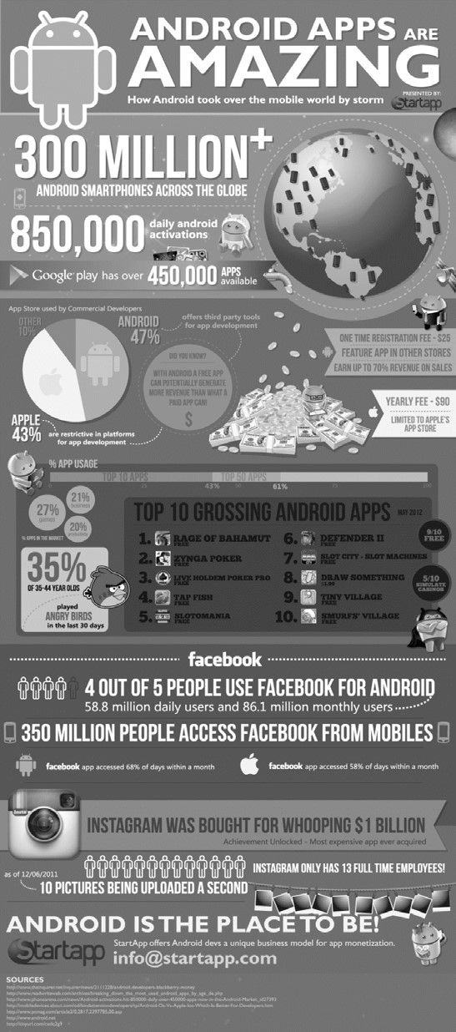How many Android smartphones exist across the globe? More than 300 million
2. Which program has over 450000 apps available? Google play
3. How much is the one-time registration fee for Android apps? 90 dollars
4. In terms of commercial developers using the App Store, what percentage are Android-based and what percentage are Apple-based?

Android based- 47% apple based - 43%

1. Pick out one piece of information that indicates the competition between Android and Apple.

It’s the pie chart and with android a free app can potentially generate more revenue than what a paid app can

1. What percentage of 35–44 year olds played Angry Birds in the last 30 days? 35%
2. How much would you need to pay for the Tiny Village app? Free
3. According to the advert, how many people use Facebook for Android? How many monthly users does that represent? 4 out of 5 people and 86.1 million monthly users
4. According to the advert, what is the total number of people who access Facebook from their mobile phones? 350 million people
5. How many full-time employees does Instagram have? 13 employees
6. How much money was Instagram bought for? 1 billion
7. Which company has placed this advert? What does it do? Start app Develops unique business model for app monetization
8. Which is the email address you would use to get in touch with the advertiser? [info@startapp.com](mailto:info@startapp.com)

Group 1 - Members

Runisi Nikoya Samaranayake - 20221247

Nina Abeyratne - 20221754

Samrithaa Jeevaratnam -20221530

Pramuditha Vishwajith - 20221588

Shafky - 20200930

ireshweliserage - 20221278

Ammaar - 20221721

Source: www.startapp.com/android-appsinfographic/android-apps-infographic.pdf

**ACTIVITY THREE:** Peep into the box above. Scan it and circle the words starting with **W.** You have only 3 minutes.

Skimming is one of the tools you can use to read more in less time. **Skimming** refers to looking only for the general or main ideas, and works best with non-fiction (or factual) material. With skimming, your overall understanding is reduced because you don’t read everything. You read only what is important to your purpose. Skimming takes place while reading and allows you to look for details in addition to the main ideas.

How to skim.? Many people think that skimming is a haphazard process placing the eyes where ever they fall. However, to skim effectively, there has to be a structure but you don’t read everything. What you read is more important than what you leave out. So what material do you read and what material do you leave out?

Let’s say you are doing research on a long chapter or a web site. By reading the first few paragraphs in detail, you will get a good idea of what information will be discussed. Once you know where the reading is headed, you can begin to **read only the first sentence of each paragraph**. Also called topic sentences, they give you the main idea of the paragraph. If you do not get the main idea in the topic sentence or if the paragraph greatly interests you, then you may want to skim more.

At the end of each topic sentence, your eyes should drop down through the rest of the paragraph, looking for important pieces of information, such as names, dates, or events. Continue to read only topic sentences, dropping down through the rest of the paragraphs, until you are near the end. Since the last few paragraphs may contain a conclusion or summary, you should stop skimming there and read in detail. Remember that your overall comprehension will be lower than if you read in detail. If while skimming, you feel you are grasping the main ideas, then you are skimming correctly.

When to skim. Because skimming is done at a fast speed with less-than-normal comprehension, you shouldn’t skim all the time. There are many times, however, when skimming is very useful.

Suppose you are taking a presentation skills class and have to deliver an oral report in a few days about the first computers ever made. You locate six books and four newspaper articles about this topic. Because you must be ready soon, you do not have time to read each word, but you need a large quantity of solid information.